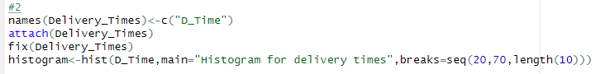

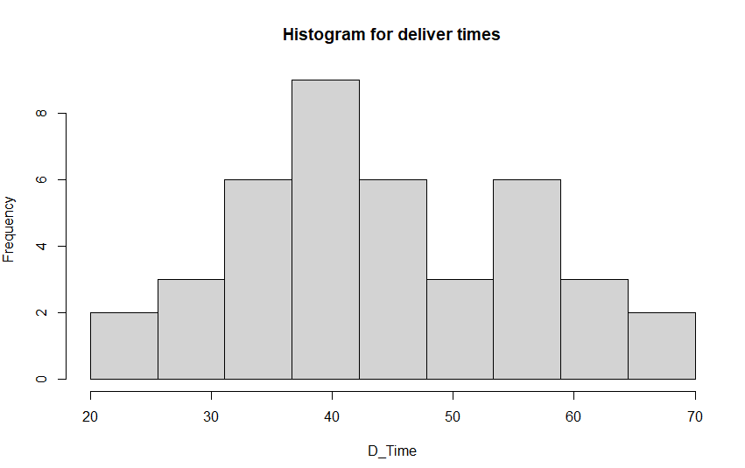

3) The distribution of delivery times is slightly positively skewed, indicating that most deliveries are concentrated around lower times, but a few take longer.



